HAPPY BIRTHDAY, FRIEDRICH SCHILLER!
November 10, 1759-May 9, 1805
THE POET OF FREEDOM
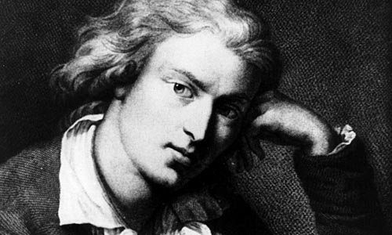
CELEBRATE SCHILLER’S BIRTHDAY WITH POETRY, MUSIC, PRESENTATIONS, AND FOOD.
Saturday, November 11th, 1 pm – 4 pm
Good Shepherd Faith Presbyterian Church
152 W. 66th St., NYC
“No, there is a limit to the tyrant's power, /When the oppressesd can find no justice,/ When the burden grows unbearable—he reaches / With hopeful courage up unto the heavens /And seizes hither his eternal rights, / Which hang above, inalienable / And indestructible as stars themselves.” Friedrich Schiller, Wilhelm Tell, 1804
Schiller – historian, dramatist, poet –made the greatest demands on the beautiful potential of all human nature. Beethoven chose Schiller’s poem “The Ode to Joy” to conclude his Ninth Symphony. Helga Zepp LaRouche founded the Schiller Institute in 1994, promoting global development and the related necessity of the aesthetical education of man. Wilhelm von Humboldt moved to Jena to converse nightly with Schiller, particularly from 1794-1797, and wrote of Schiller: “Art and poetry were directly joined to that which is most noble in humanity, were presented as that by which humanity first awakens to the consciousness of its indwelling nature, which strives to transcend the finite. Thus, both art and poetry were placed at the pinnacle from which they truly derive. This placement, protected from desecration by any petty and degrading opinion, from any sentiment not derived from their pure elements, was, in the truest sense, Schiller’s constant endeavor, and appears as his true destiny in life, given him by the original direction of his life. The primary and most stringent demands were therefore made on the poet himself, from whom he demands not merely a genius and talent working, as it were, in isolation, but rather a total attunement of mind fit for the high elevation of his vocation, not merely a momentary sublimity, but one that has become character. [Schiller write in 1791, On Bürger’s Poetry] ‘Before he undertakes to deal with excellence, he is to make his first and most important task the refinement of his own individuality to the purest and most glorious of humanity’’.”
EVERYONE IS REQUESTED TO BRING YOUR FAVORITE DISH OR DESERT
FOR THE EVENT! Call 201-562-9890 $20 Suggested Donation

